University of Central Missouri

Department of Computer Science & Cybersecurity

CS5760 Natural Language Processing

Spring 2026

Homework 4.

Student name:Sharath chandra seriyala700776646

Submission Requirements:
- Once finished your assignment push your source code to your repo (GitHub) and explain the work through the ReadMe file properly. Make sure you add your student info in the ReadMe file.
- Submit your GitHub link on the Bright Space.
- Comment your code appropriately IMPORTANT.
- Any submission after provided deadline is considered as a late submission.

Q6. Multi-Input Feedforward
Consider a neural network with 3 inputs x1=2, x2=1, x3=3, one hidden layer of 2 sigmoid units, and one sigmoid output.
Weights:
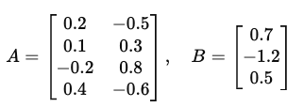
- A includes biases (last row).
- B includes bias (last element).
Tasks
a) Compute hidden pre-activations and activations.
b) Compute the output activation y.
c) If the true label is t=1, calculate the binary cross-entropy loss.

Q7. XOR with ReLU Network
We use the XOR ReLU network from the slides
Extend it with an additional hidden unit:
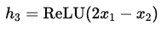
and new output:
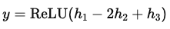
Tasks
a) Compute outputs for all four XOR inputs (0,0),(0,1),(1,0),(1,1).
b) Compare the decision boundary with the original 2-hidden-unit XOR network.
c) Does this extension still compute XOR exactly? If not, which inputs differ?

Q8. Decision Boundary and Misclassification
You train a perceptron with decision rule:
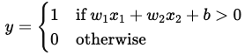
with parameters w1=1, w2=−2, b=1.
Dataset:
(2,1)→1, (1,3)→0, (3,2)→1, (0,1)→0.
Tasks
a) Write the decision boundary equation and sketch it.
b) Classify each point using the perceptron rule. Which ones are misclassified?
c) Compute the perceptron loss (number of mistakes).
d) If we apply one weight update with learning rate η=0.5 on the first mistake, what are the new weights?

Part I. Short Answer

Q3. Neural Networks: Structure, Activation, and Representation
(a) Why are non-linear activation functions (like ReLU, sigmoid, tanh) necessary in neural networks?
(b) Why are deep networks better at feature learning compared to shallow models like logistic regression?

1) RNN Families & Use-Cases (Many-to-X)
a) Map each task to the most suitable RNN I/O pattern and explain why (1–2 lines each):
• next-word prediction

• sentiment of a sentence

• NER

• machine translation
(Choose from: one-to-many, many-to-one, many-to-many aligned, many-to-many unaligned.)
b) In one sentence, explain how “unrolling” over time enables BPTT and weight sharing.
c) Give one advantage and one limitation of weight sharing across time in RNNs.
2) Vanishing Gradients & Remedies
a) Describe the vanishing gradient problem in RNNs and how it affects long-range dependencies.
b) List two architectural solutions and briefly how each helps gradient flow.
c) Give one training technique (not an architecture change) that can mitigate the issue and why.
3) LSTM Gates & Cell State
a) Explain the roles of the forget, input, and output gates. For each, name its activation and purpose.
b) Why is the LSTM cell state often described as providing a “linear path” for gradients?
c) In one or two sentences, contrast “what to remember” vs. “what to expose” in LSTMs.

4) Self-Attention
a) Define Query (Q), Key (K), and Value (V) in the context of self-attention.
b) Write the formula for dot-product attention.
c) Why do we divide by $\sqrt{d_{k}}$?

5) Multi-Head Attention & Residual Connections
a) Why do Transformers use multi-head attention instead of single-head attention?
b) What is the purpose of Add & Norm (Residual + LayerNorm)? Explain two benefits.
c) Describe one example of linguistic relation that different heads might capture (e.g., coreference, syntax).

6) Encoder–Decoder with Masked Attention
a) Why does the decoder use masked self-attention? What problem does it prevent?
b) What is the difference between encoder self-attention and encoder–decoder cross-attention?
c) During inference (no teacher forcing), how does the model generate tokens step by step?
Part II: Programming
Q1. Character-Level RNN Language Model (“hello” toy & beyond)
Goal: Train a tiny character-level RNN to predict the next character given previous characters.
Data (toy to start):
- Start with a small toy corpus you create (e.g., several “hello…”, “help…”, short words/sentences).
- Then expand to a short plain-text file of ~50–200 KB (any public-domain text of your choice).
Model:
- Embedding → RNN (Vanilla RNN or GRU or LSTM) → Linear → Softmax over characters.
- Hidden size 64–256; sequence length 50–100; batch size 64; train 5–20 epochs.
Train:
- Teacher forcing (use the true previous char as input during training).
- Cross-entropy loss; Adam optimizer.
Report:
- Training/validation loss curves.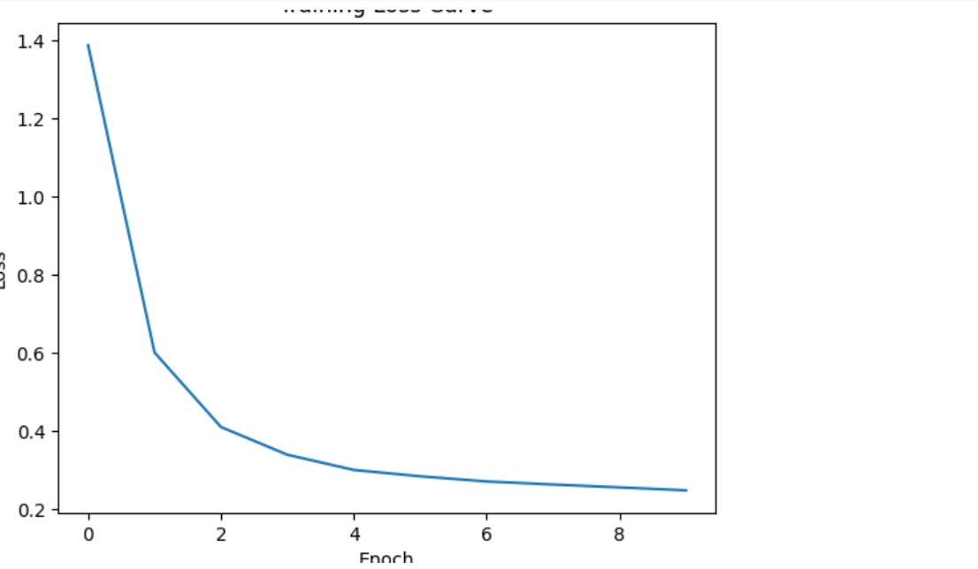

- Sample 3 temperature-controlled generations (e.g., τ = 0.7, 1.0, 1.2) for 200–400 chars each.

Temp 0.7:
her helo her helo helo helo her her her
Temp 1.0:
her heroer hel hel hep hel heelo hel

Temp 1.2:
heel hehel her her her hel her heroohelher
- A 3–5 sentence reflection: what changes when you vary sequence length, hidden size, and temperature?
(Connect to slides: embedding, sampling loop, teacher forcing, tradeoffs
Increasing the sequence length allows the model to learn longer patterns in the data, but it also increases training time and makes optimization more challenging. Using a larger hidden size gives the model more capacity to learn complex representations and can improve the quality of generated text, although it may cause overfitting when the dataset is small. Temperature influences the randomness of text generation: lower values produce more stable and repetitive outputs, while higher values increase creativity but reduce consistency. Teacher forcing improves training efficiency by feeding the correct previous character to the model instead of its own prediction during learning.

Q2. Mini Transformer Encoder for Sentences
Task: Build a mini Transformer Encoder (NOT full decoder) to process a batch of sentences.
Steps:
- Use a small dataset (e.g., 10 short sentences of your choice).
- Tokenize and embed the text.
- Add sinusoidal positional encoding.
- Implement:
  - Self-attention layer
  - Multi-head attention (2 or 4 heads)
  - Feed-forward layer
  - Add & Norm
- Show:
  - Input tokens
- Input Tokens:
- tensor([[ 1, 12, 2, 0],
[ 4, 7, 6, 0],
[10, 8, 5, 0],
[13, 11, 8, 9],
[ 2, 8, 3, 0]])
  - Final contextual embeddings

- Final Embeddings:
tensor([[[ 5.6026e-01, 1.0471e+00, -1.2386e+00, 6.5785e-01, 3.6395e-01,
- 2.3107e-01, -8.0719e-01, -5.9881e-02, -1.7563e-01, -1.4657e-01,
- 1.5765e-01, 5.3607e-01, 1.3573e-01, -1.6193e+00, -8.7278e-01,
- 6.3444e-01, -7.9386e-01, 9.7592e-01, -1.5527e+00, -3.7889e-01,
- -4.1513e-01, 1.5226e+00, 3.3277e-01, 1.0309e-01, -1.3495e-02,
- 5.7546e-01, -9.9196e-01, 2.6638e+00, -2.4013e+00, 5.9005e-01,
- 1.2540e+00, -8.7467e-01],
- [ 2.6209e+00, 8.9162e-02, -6.8349e-01, 3.6507e-01, -2.8573e-01,
- 1.5147e+00, 1.2670e+00, -4.9894e-01, -4.1142e-01, 4.2454e-02,
- -3.3968e-01, 5.0499e-01, 1.0342e+00, -3.1750e-01, -8.1379e-01,
- 3.2796e-01, 3.6478e-01, 8.2856e-02, -1.9299e+00, 7.8947e-01,
- -6.7614e-01, 9.8265e-01, -1.2992e+00, 1.9656e-01, -1.4617e+00,
- 5.9626e-01, -1.9716e+00, 8.3331e-02, -1.3982e+00, 8.8901e-01,
- -5.3384e-01, 8.6969e-01],
- [-3.5003e-02, -1.1213e+00, 1.0929e+00, -2.3359e+00, 1.4791e-01,
- -5.2284e-01, 7.5629e-01, 3.2475e-01, -4.3411e-01, -5.8842e-02,
- -6.0963e-01, 9.1586e-01, -4.3776e-01, 1.2269e+00, 6.3549e-01,
- 6.5035e-01, -1.6766e-01, 7.4743e-01, -6.3069e-01, 1.4239e+00,
- -6.0031e-01, 5.4894e-01, -3.1560e-02, -1.4958e+00, -2.3592e+00,
- 2.1997e-01, -6.3889e-01, 1.0562e+00, -8.7306e-01, -5.7082e-01,
- 1.6534e+00, 1.5231e+00],
- [ 2.6920e+00, -1.3928e+00, 7.1764e-02, -2.7356e-01, 7.6057e-01,
- -3.5002e-01, -1.4561e-01, 1.8302e+00, 1.0291e+00, -1.2726e+00,
- 1.2235e+00, -4.5374e-02, -9.6775e-01, 1.5290e+00, 3.3773e-02,
- 6.3772e-01, -1.2460e+00, -2.0121e-01, -1.6397e+00, -3.3396e-01,
- -5.0023e-01, 7.8962e-01, -4.9396e-01, -1.6795e-02, -1.4907e-01,
- -4.0727e-01, -1.5299e+00, -5.6930e-01, -1.0415e+00, 5.2007e-01,
- 6.3627e-01, 8.2297e-01]],

- [[ 7.1781e-01, -3.2145e-01, 2.7424e-01, 4.6062e-01, -1.0326e+00,
- -4.9446e-01, -1.0836e+00, 3.4217e-01, -8.6675e-01, 1.4099e+00,
- 2.4270e-01, -9.8543e-02, 1.2993e+00, 6.6072e-01, -7.3868e-01,
- -1.4246e-01, -1.1247e+00, 1.3627e+00, -3.0524e+00, -6.2615e-01,
- -1.3817e+00, 5.9350e-01, -1.3152e+00, 4.0606e-01, 2.4204e-01,
- 2.6833e-01, -2.3236e-01, 1.3046e+00, -1.8298e-01, 1.7936e+00,
- 6.9779e-01, 6.1804e-01],
- [ 3.5531e-01, 3.7677e-01, 3.0380e-01, 1.4586e+00, 1.0796e+00,
- 4.7755e-01, 1.7697e+00, 4.6271e-01, -8.8951e-01, 8.7597e-01,
- -5.6311e-01, 1.5749e+00, -1.2816e+00, 1.0508e+00, -4.1684e-01,
- -7.8956e-02, -7.7514e-01, -1.4678e+00, -3.2736e-01, 1.0203e+00,
- -1.4589e+00, 2.5178e-01, -1.2228e+00, -9.1074e-01, -1.7395e+00,
- -4.3025e-01, -1.4749e+00, 1.3191e+00, -7.2081e-01, -8.9311e-02,
- 3.2618e-01, 1.1444e+00],
- [ 2.1428e+00, -8.2425e-01, 8.9715e-01, 1.3478e+00, -1.2432e-01,
- -3.8864e-01, 2.9145e-01, 9.1128e-01, 9.5219e-01, -2.3832e-01,
- 8.3357e-01, -3.6923e-01, -1.0738e+00, 6.4459e-02, -1.6765e+00,
- -1.3015e+00, -3.6033e-01, -1.9854e-01, 4.3526e-01, 7.8701e-01,
- -9.9886e-01, 9.7321e-01, -2.4987e+00, 1.4505e+00, -7.1635e-01,
- 6.7757e-01, -1.6186e+00, 2.6410e-01, 6.3322e-01, -2.3797e-01,
- -3.1679e-01, 2.8106e-01],
- [ 2.6206e+00, -1.4649e+00, 3.8708e-01, -6.1941e-02, 9.6550e-01,
- -5.3479e-01, -4.7992e-01, 1.8275e+00, 7.4771e-01, -8.1682e-01,
- 1.4965e+00, -2.0499e-01, -1.0031e+00, 1.6304e+00, -8.7676e-02,
- 2.7850e-01, -1.3557e+00, -3.0269e-01, -1.7513e+00, 1.3118e-02,
- -8.9298e-01, 7.5860e-01, -5.8330e-01, 2.0559e-02, -9.3292e-02,
- -2.9815e-01, -1.3053e+00, -6.1887e-01, -7.1664e-01, 4.0329e-01,
- 3.9238e-01, 1.0306e+00]],

- [[ 1.8989e-01, 4.2991e-01, -1.4261e+00, 8.3395e-02, -3.0376e-01,
- 1.9128e+00, 9.4492e-01, -9.4207e-02, 1.0151e+00, -1.4900e+00,
- -1.3153e+00, -2.5109e-01, -2.3734e-01, -9.3523e-01, -7.7269e-01,
- 7.6143e-01, 8.0656e-01, 1.8937e+00, 2.9761e-01, 9.3855e-01,
- -2.0102e-01, 3.9129e-01, -9.0707e-01, 5.3321e-01, -2.6359e+00,
- -2.7257e-01, -1.4328e+00, 3.7183e-01, -3.0380e-01, 1.3695e+00,
- 1.7488e-01, 4.6445e-01],
- [ 1.2535e+00, 1.5906e-01, -1.6451e+00, -7.3486e-01, 6.9084e-01,
- -5.9726e-01, 7.0985e-01, 1.9094e+00, -1.0488e+00, -5.8146e-01,
- 1.0994e+00, 1.8521e-01, 9.8908e-01, 7.8781e-01, -5.5457e-02,
- 1.9043e+00, 1.2416e+00, 1.1889e+00, -2.9745e-02, -7.4075e-01,
- 3.1808e-01, -8.4496e-01, -1.3508e+00, -4.5544e-01, -4.1467e-01,
- 1.5937e-01, -1.2180e+00, 8.1039e-01, -1.6791e+00, -5.7991e-01,
- 1.1997e-01, -1.5505e+00],
- [ 1.0910e+00, 1.3444e+00, -6.2662e-01, -2.8307e-01, 2.7417e-01,
- -5.1663e-01, -2.5718e-01, -1.2922e+00, 4.2467e-01, 5.4218e-02,
- 1.2127e+00, 2.1441e-01, -2.0142e-01, 6.5320e-01, -1.7751e+00,
- 1.4233e+00, -7.4898e-01, -8.4171e-02, 1.0764e+00, -8.5077e-01,
- -2.0380e+00, 5.4903e-02, 1.1811e+00, 2.2430e+00, -7.7538e-01,
- 9.3171e-01, -3.7193e-01, -1.6625e+00, 1.5903e-01, -1.2229e+00,
- 4.2280e-01, -5.4283e-02],
- [ 2.7475e+00, -1.1221e+00, 3.8201e-01, 2.8188e-01, 8.1373e-01,
- -8.1385e-01, -1.6635e-01, 1.8596e+00, 6.8751e-01, -6.5038e-01,
- 1.2692e+00, -7.2942e-01, -6.4135e-01, 1.4731e+00, 1.7873e-02,
- 4.2030e-01, -1.4837e+00, -3.7179e-01, -1.0749e+00, -4.7545e-01,
- -8.0328e-01, 1.2614e+00, -6.6036e-01, 2.7745e-01, -3.7484e-01,
- -4.2546e-01, -1.7360e+00, -8.2777e-01, -7.9192e-01, 4.9835e-01,
- 1.7890e-01, 9.8011e-01]],

- [[-1.0601e+00, 6.2952e-02, -1.7632e-01, 1.6639e+00, 4.0933e-02,
- 3.2487e-02, 4.9636e-01, -9.9942e-01, 9.3051e-01, 2.1404e+00,
- -9.3517e-01, -1.9272e-01, -3.4331e-01, -1.2170e-01, -1.3282e+00,
- 7.0643e-01, -1.9727e+00, 7.8238e-01, -4.1298e-01, 2.4779e-01,
- -1.8894e+00, 1.0459e+00, -2.0183e+00, 1.1851e-01, 3.9238e-01,
- 1.8864e-02, -6.7098e-01, 7.8837e-01, 2.1721e-01, 8.9008e-01,
- -4.0166e-02, 1.5860e+00],
- [-8.3486e-01, 1.1838e+00, 6.8080e-01, 5.8354e-01, 1.0420e+00,
- 6.9392e-01, 8.0034e-01, -2.4839e-01, -5.8039e-01, 7.3801e-01,
- -1.6454e+00, 9.1328e-01, -7.8361e-01, 5.4694e-02, 1.1246e-01,
- 1.0773e-01, -1.2902e-01, 8.4775e-01, -4.2996e-01, 2.4619e-01,
- -8.1234e-01, -7.6394e-02, -8.9593e-01, -1.3717e+00, -1.7821e+00,
- -8.3980e-01, -1.6758e-01, 2.8862e+00, -4.3077e-01, 6.0450e-01,
- 1.2720e+00, -1.7391e+00],
- [ 1.1776e+00, -5.3110e-01, -1.3882e+00, -1.4753e+00, 1.1369e+00,
- -6.5701e-01, 9.1612e-01, 1.5638e+00, -9.1327e-01, -2.7458e-01,
- 9.4038e-01, 3.1272e-01, 7.5042e-01, 8.4968e-01, 2.0248e-01,
- 1.7413e+00, 8.1829e-01, 1.5802e+00, -2.7902e-01, -2.9085e-01,
- 4.4099e-01, -1.2514e+00, -1.2484e+00, -6.8733e-01, -4.9272e-01,
- -2.1323e-03, -8.4854e-01, 1.0454e+00, -1.7154e+00, -3.2090e-01,
- 4.8470e-01, -1.5848e+00],
- [-2.2915e-01, 1.8315e-01, 7.6217e-01, -1.8725e+00, 8.5727e-01,
- 9.1515e-01, 9.2706e-01, 1.3953e+00, -7.2583e-01, -7.6849e-01,
- -9.1737e-01, -2.7437e-01, 1.4025e-01, -8.0281e-01, -1.8694e-02,
- -3.9008e-01, -4.2595e-01, 1.3430e+00, -3.1172e-01, 2.1349e+00,
- -1.7018e+00, 1.9313e-01, 7.0451e-02, 4.6211e-01, -6.8462e-01,
- 7.0670e-01, -1.5689e+00, 1.7146e+00, -3.1712e-01, 1.0536e+00,
- -1.7951e+00, -5.4214e-02]],

- [[-6.7384e-01, -6.8615e-03, 5.7884e-01, -1.9063e+00, -9.9912e-02,
- -5.0633e-01, 6.3091e-01, 3.2143e-01, -7.2060e-01, 1.2139e-01,
- -7.9237e-01, 7.8402e-01, -3.8576e-01, 1.3760e+00, 7.7646e-01,
- 5.6273e-01, -5.5055e-02, 7.7509e-01, -5.6274e-01, 1.5292e+00,
- -8.5380e-01, 7.5744e-01, -1.1404e-02, -1.4807e+00, -2.6271e+00,
- 1.7166e-01, -6.4481e-01, 9.5336e-01, -8.1839e-01, -6.4812e-01,
- 1.7383e+00, 1.7174e+00],
- [ 1.2466e+00, 1.4637e-01, -1.7884e+00, -9.4374e-01, 4.7699e-01,
- -1.4156e-01, 7.0654e-01, 1.6466e+00, -8.2423e-01, -8.8394e-01,
- 9.9389e-01, 5.9489e-01, 7.8550e-01, 8.6436e-01, 4.8050e-02,
- 1.8259e+00, 1.3251e+00, 1.3152e+00, -3.7195e-01, -5.4146e-01,
- 3.3114e-01, -1.0307e+00, -1.1773e+00, -5.7690e-01, -4.3427e-01,
- 1.8798e-01, -1.0575e+00, 9.0400e-01, -1.8078e+00, -5.4365e-01,
- 3.6947e-01, -1.6452e+00],
- [ 7.4644e-01, -4.3996e-01, 5.7869e-02, 1.0566e+00, -4.3265e-01,
- 6.3765e-01, 2.8877e-01, 1.1633e+00, -1.5112e-01, 2.1200e-01,
- -3.0041e-02, 3.3189e-02, -4.2529e-02, 3.8734e-02, -2.8958e-01,
- 1.3947e+00, -2.5303e+00, 5.9055e-01, -2.9977e+00, 1.1390e+00,
- -8.5807e-01, -1.6834e-02, -1.2536e+00, 3.6162e-01, -4.2036e-01,
- 1.8360e-01, -6.6052e-01, 6.4881e-01, -1.3933e+00, 4.7611e-01,
- 9.3292e-01, 1.5547e+00],
- [ 2.7718e+00, -1.2954e+00, 8.9477e-02, -3.5516e-02, 7.5818e-01,
- -3.4968e-01, -6.7024e-02, 1.6817e+00, 9.0207e-01, -1.0938e+00,
- 1.2390e+00, -2.5500e-01, -8.4899e-01, 1.7190e+00, 1.3937e-01,
- 5.0497e-01, -1.2979e+00, -1.8614e-01, -1.5323e+00, -2.8232e-01,
- -8.3469e-01, 9.4426e-01, -4.9777e-01, 1.1069e-01, -3.4498e-01,
- -3.8338e-01, -1.6265e+00, -7.4544e-01, -9.7939e-01, 4.7003e-01,
- 5.6678e-01, 7.5890e-01]]], grad_fn=<NativeLayerNormBackward0>)

  - Attention heatmap between words (visual or printed)
  - 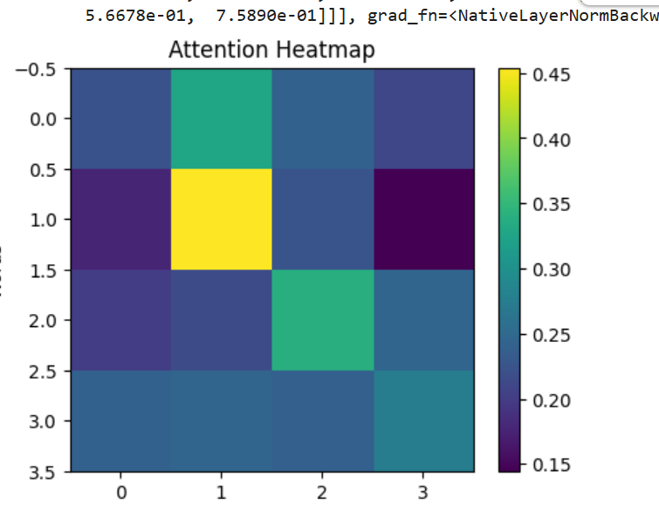
  - It shows the attention weights between words in the first sentence. The color intensity represents the strength of the attention. A brighter color at the intersection of a 'Query' word and a 'Key' word indicates that the 'Query' word pays more attention to the 'Key' word.

Q3. Implement Scaled Dot-Product Attention
Goal: Implement the attention function from your slides:
$$\text{Attention}(Q,K,V)=\text{softmax}(\frac{QK^{T}}{\sqrt{d_{k}}})V$$
Requirements:
- Write a function in PyTorch or TensorFlow to compute attention.
- Test it using random Q, K, V inputs.
- Print:
  - Attention weight matrix
  - Output vectors
  - Softmax stability check (before and after scaling)
Unscaled Attention Scores:
  - tensor([[0.7958, 0.2353],
  - [1.0721, 0.7228]])

  - Scaled Attention Scores:
  - tensor([[0.3979, 0.1176],
  - [0.5361, 0.3614]])

  - Attention Weights:
  - tensor([[0.5696, 0.4304],
  - [0.5436, 0.4564]])

  - Final Output:
  - tensor([[0.6908, 0.8496, 0.2626, 0.5370],
  - [0.6903, 0.8526, 0.2688, 0.5524]])
A softmax stability check compares the values of attention scores before scaling and after scaling (by √dₖ) to understand why scaling is important in Transformer models.
Before Scaling (Raw Scores)
When we directly apply softmax on raw dot-product scores, the values can become very large or very small. This causes:
- Extremely peaked probabilities (one value becomes almost 1)
- Very small gradients
- Poor learning stability
This happens because dot products grow with vector dimension.

After Scaling (Dividing by √dₖ)
In scaled dot-product attention, scores are divided by √dₖ before applying softmax.
This:
- Reduces large score values
- Keeps values in a stable range
- Produces smoother probability distribution
- Improves gradient flow during training

